

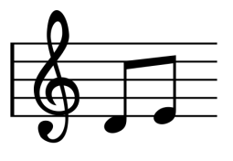

Audio File

Chemical Library

Simple

Musical

Rules